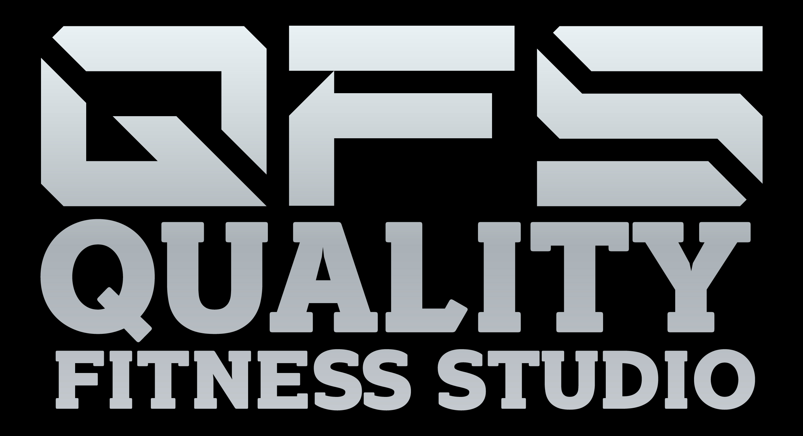

Health: Fitness Center Waiver and Release of Liability
In consideration of my use of the exercise equipment and facilities provided by the company, I expressly agree and contract, on behalf of myself, my heirs, executors, administrators, successors and assigns, that the company and its insurers, employees, officers, directors, and associates, shall not be liable for any damages arising from personal injuries (including death) sustained by me, or my guest in, on, or about the premises, or as a result of the use of the equipment or facilities, regardless of whether such injuries result, in whole or in part, from the negligence of the company.
By the execution of this agreement, I accept and assume full responsibility for any and all injuries, damages (both economic and non-economic), and losses of any type, which may occur to me or my guest, and I hereby fully and forever release and discharge the company, its insurers, employees, officers, directors, and associates, from any and all claims, demands, damages, rights of action, or causes of action, present or future, whether the same be known or unknown, anticipated, or unanticipated, resulting from or arising out the use of said equipment and facilities.
I expressly agree to indemnify and hold the company harmless against any and all claims, demands, damages, rights of action, or causes of action, of any person or entity, that may arise from injuries or damages sustained by me or my guest.
I agree to be solely responsible for safety and well being of my guest and myself. I understand that the company does not provide supervision, instruction, or assistance for the use of the facilities and equipment.
I agree to comply with all rules imposed by the company regarding the use of the facilities and equipment. I agree to conduct myself in a controlled and reasonable manner at all times, and to refrain from using any equipment in a manner inconsistent with its intended design and purpose.
I understand and acknowledge that the use of exercise equipment involves risk of serious injury, including permanent disability and death.
I understand and agree that the company is not responsible for property that is lost, stolen, or damaged while in, on, or about the premises.
I understand and agree that my use of the facilities and equipment is only to be undertaken on my own personal time, and that my use of the facilities and equipment is not within the course or scope of my employment.
I HAVE READ THE FOREGOING WAIVER AND RELEASE OF LIABILITY AND VOLUNTARILY EXECUTED THIS DOCUMENT WITH FULL KNOWLEDGE OF ITS CONTENT.
Date:_____________________
______________________________ _______________________________
Signature: Print Name
_____________________________________ ______________________________
Parent/Guardian Signature for under 18 Print Name

